[Artif](https://doi.org/10.1016/j.aiia.2023.08.002)i[cial Intelligence in Agriculture 9 (2023) 36–45](https://doi.org/10.1016/j.aiia.2023.08.002)

|  |  |  |  |  |  |
| --- | --- | --- | --- | --- | --- |
|  | |  | | --- | | Contents lists available at [ScienceDirect](http://www.sciencedirect.com/science/journal/) |  |  | | --- | | Artificial Intelligence in Agriculture |  |  | | --- | | journal homepage: [http://www.keaipublishing.com/en/journals/artificial-](http://www.keaipublishing.com/en/journals/artificial-intelligence-in-agriculture/) |   [intelligence-in-agriculture/](http://www.keaipublishing.com/en/journals/artificial-intelligence-in-agriculture/) |  |
| Detecting broiler chickens on litter floor with the YOLOv5-CBAM deep learning model | |  |

Yangyang Guoa,b, Samuel E. Aggreyb, Xiao Yangb, Adelumola Oladeindec, Yongliang Qiaod, Lilong Chaib,⁎

a School of Internet, Anhui University, Hefei, Anhui 230039, China   
b Department of Poultry Science, University of Georgia, Athens, GA 30602, USA   
c U.S. National Poultry Research Center, USDA-ARS, Athens, GA 30605, USA   
d Australian Centre for Field Robotics (ACFR), Faculty of Engineering, The University of Sydney, NSW 2006, Australia

|  |  |  |
| --- | --- | --- |
| a r t i c l e | i n f o | a b s t r a c t |
| Article history:  Received 5 April 2023  Received in revised form 16 July 2023 Accepted 8 August 2023  Available online 9 August 2023 | | For commercial broiler production, about 20,000–30,000 birds are raised in each confined house, which has caused growing public concerns on animal welfare. Currently, daily evaluation of broiler wellbeing and growth is conducted manually, which is labor-intensive and subjectively subject to human error. Therefore, there is a need for an automatic tool to detect and analyze the behaviors of chickens and predict their wel-fare status. In this study, we developed a YOLOv5-CBAM-broiler model and tested its performance for de- |
| Keywords:  Poultry production  Deep learning  YOLOv5  Attention mechanism | | tecting broilers on litter floor. The proposed model consisted of two parts: (1) basic YOLOv5 model for bird or broiler feature extraction and object detection; and (2) the convolutional block attention module (CBAM) to improve the feature extraction capability of the network and the problem of missed detection of occluded targets and small targets. A complex dataset of broiler chicken images at different ages, multiple pens and scenes (fresh litter versus reused litter) was constructed to evaluate the effectiveness of the new |

model. In addition, the model was compared to the Faster R-CNN, SSD, YOLOv3, EfficientDet and YOLOv5 models. The results demonstrate that the precision, recall, F1 score and an mAP@0.5 of the proposed method were 97.3%, 92.3%, 94.7%, and 96.5%, which were superior to the comparison models. In addition, comparing the detection effects in different scenes, the YOLOv5-CBAM model was still better than the com-parison method. Overall, the proposed YOLOv5-CBAM-broiler model can achieve real-time accurate and fast target detection and provide technical support for the management and monitoring of birds in commer-cial broiler houses.

© 2023 The Authors. Publishing services by Elsevier B.V. on behalf of KeAi Communications Co., Ltd. This is an open access article under the CC BY-NC-ND license (<http://creativecommons.org/licenses/by-nc-nd/4.0/>).

|  |  |
| --- | --- |
| 1. Introduction | Computer vision technology (CVT) is widely used to monitor |

farm animals because it is non-invasive (Qin et al., 2021; Wang

Poultry provides a valuable source of proteins but face a number of challenges worldwide. Among the many challenges is the welfare concerns of the birds under intensive management systems (Chai et al., 2018, 2019). Due to the large number of chickens reared at any given time in a house, accurate and efficient monitoring of birds can improve their health and welfare status (Li et al., 2021; Okinda et al., 2020). Currently, most broiler houses are monitored manually, however, this approach could be both laborious and erroneous. Automatic broiler monitoring system could collect individual bird data within a flock and provide critical information to aid digital management (Subedi et al., 2023a, 2023b; Yang

et al., 2022; He et al., 2016). The CVT together with machine vision methods have achieved target detection based on the features of the target area (e.g., color, shape, texture). The ability to effectively acquire these visual features will affect the accuracy of target detec-tion (Tharwat et al., 2014; Awad et al., 2013; Andrew et al., 2017). The feature acquisition method, external environment (e.g., light intensity and occlusion), shooting angle and image quality chosen are crucial parameters that will affect target detection. Therefore, it is important to innovate animal target detection algorithms that are less affected by the natural environment.

Deep learning technology has powerful feature representation capa-

et al., 2022). bilities, fast processing speed, and can resolve problems associated with

external interferences. Thus, deep learning algorithms are appropriate

models for developing an automatic, efficient and intelligent tool for an-

⁎ Corresponding author.

E-mail address: [lchai@uga.edu](mailto:lchai@uga.edu) (L. Chai).

<https://doi.org/10.1016/j.aiia.2023.08.002>

imal farming (Qiao et al., 2021). Deep learning technologies have been applied to the study of large animals (pigs, sheep, cattle), such as object

2589-7217/© 2023 The Authors. Publishing services by Elsevier B.V. on behalf of KeAi Communications Co., Ltd. This is an open access article under the CC BY-NC-ND license ([http:// creativecommons.org/licenses/by-nc-nd/4.0/](http://creativecommons.org/licenses/by-nc-nd/4.0/)).

Y. Guo, S.E. Aggrey, X. Yang et al.

detection, individual tracking, behavior recognition and body condition evaluation (Chen et al., 2021; Xue et al., 2021; Tian et al., 2019; Qiao

2. Material and methods

et al., 2019; Shen et al., 2020; Alvarez et al., 2019; Guo et al., 2021a, 2.1. Data acquisition

2022). However, the size of the chicken and the sheer numbers that

are raised in a single house (e.g., 20,000–30,000 chickens on litter floor of 2000–2500 m2) pose challenges in applying deep learning tech-niques in monitoring individual chickens (Guo et al., 2020). Yang et al. (2022) built a YOLOv5x-hens model, which detection is highly efficient and over 95% accurate. Fang et al. (2020) proposed poultry tracking al-gorithm TBroiler tracker which has good performance in overlap rate, pixel error and failure rate, and its hybrid tracking performance evalua-tion (MTPE) is 0.730. Fang et al. (2021) analyzed the behavior of broiler

The data for this study came from an experimental broiler house at the Poultry Research Center of the University of Georgia, USA (Guo et al., 2020; Guo et al., 2021b). Two different litter types (fresh pine shavings and reused litter previously used to raise three flocks of broilers) were selected as application scenes for broiler de-tection. For the two litter scenes, 70 images were selected from d2, d9, d16, and d23, respectively, for a total of 560 images. In addition, to evaluate the detection performance of the model under multiple

using DNNs. pens scenes, the image samples shown in Fig. 1c were constructed,

The tests showed that the accuracy of standing, walking, running, eat-ing, resting and tidying behavior recognition was 0.7511, 0.5135, 0.6270, 0.9361, 0.9623 and 0.9258, respectively. Although the above research has made some progresses, however, there is a lack of poultry research at dif-ferent ages, feeding environments, and densities. And object detection is the premise of behavior recognition and target tracking, and it is also the data basis for providing target area information. Therefore, target detec-tion of broiler groups in multiple scenarios is of great significance. Among the deep learning algorithms, YOLO series is one of the fast and high precision algorithms for multi-target detection at present (Subedi

in which 70 images were selected for d16 and d23. Finally, 700 im-ages were obtained and randomly assigned at a ratio of 5:2 into training and testing set, respectively. Fig. 1 are examples of broiler images from different scenes.

2.2. YOLOv5-CBAM model for broiler detection

In the current study, we propose a YOLOv5-CBAM-broiler model (Fig. 2). This method added CBAM attention modules to the backbone and neck layers of YOLOv5 to improve the feature representation

et al., 2023a, 2023b; Ge et al., 2021;Bochkovskiy et al., 2020). When tar- capability.

gets are small or occluded YOLO can result in missed or false detections.

There are attention mechanisms in deep learning that can reduce infor-mation loss and improve the detection performance of occlusion and small object.(Yang et al., 2023; Li et al., 2020; Fukui et al., 2019).

In the current study, we incorporated a convolutional block atten-tion module (CBAM) into YOLOv5 to enhance the algorithm's ability to extract image features. To do this, we used a complex dataset of broiler images (e.g., birds at different ages, fresh and reused litter and multiple pens) to train and test the model. The proposed YOLOv5-CBAM improved the acquisition ability of small object features and the accuracy of small target detection.

2.2.1. The YOLOv5 network   
 Jocher et al. (2020) developed the YOLOv5 algorithm and demon-strated that it was more accurate and faster compared to the previous YOLO model. The YOLOv5s network consists of three parts: backbone, neck, and prediction. Broiler chicken images were used as input for the backbone to obtain image features, the neck part was used to inte-grate the extracted feature information and generate feature maps, and the prediction part was used to generate bounding boxes and pre-dict categories for the generated feature maps. The detailed process is provided as a supplementary material.

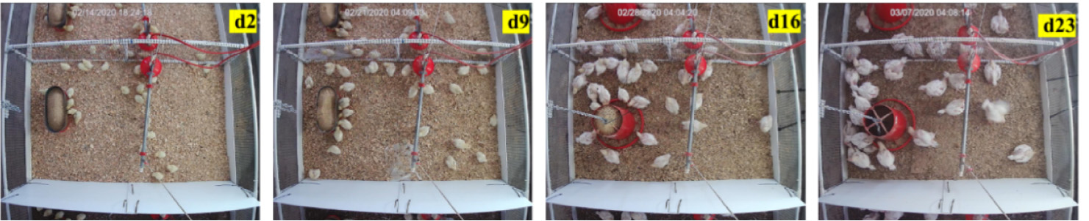



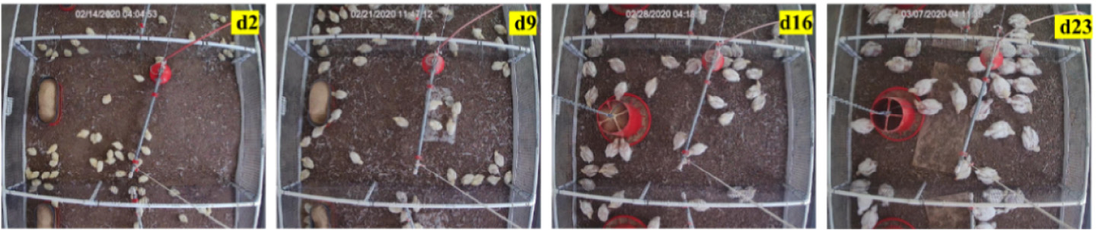



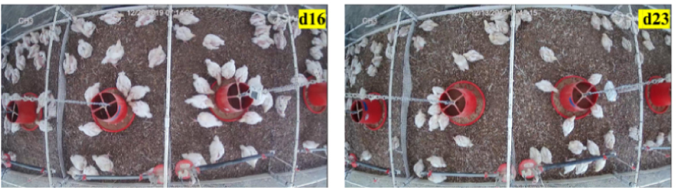



Fig. 1. Examples of broiler images from different scenes.   
37

Y. Guo, S.E. Aggrey, X. Yang et al. Artificial Intelligence in Agriculture 9 (2023) 36–45

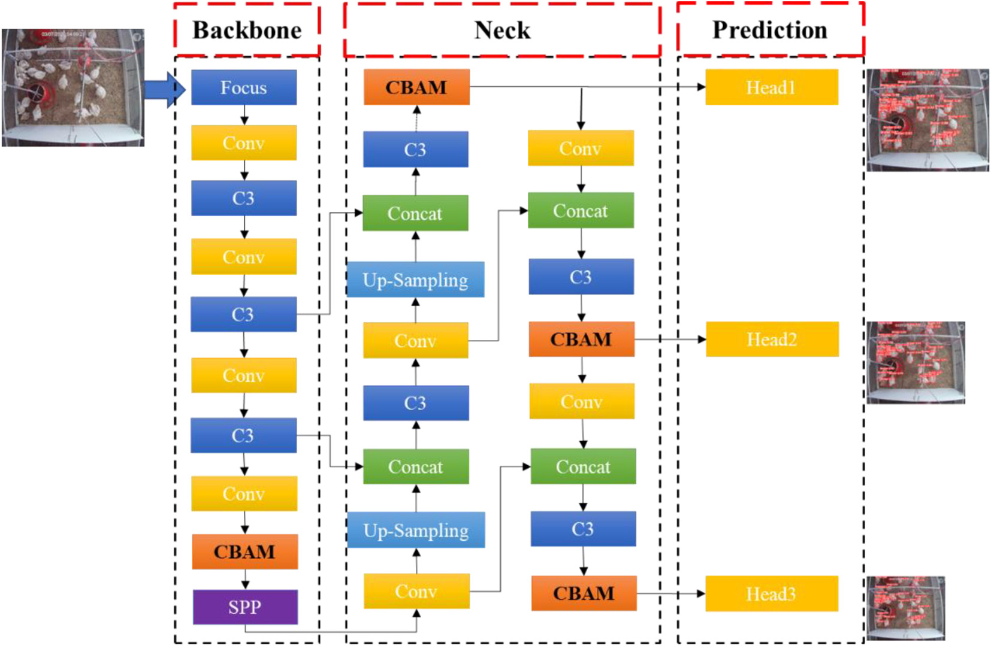

Fig. 2. The overall structure of YOLOv5-CBAM network.

The Backbone part of the model is used to extracted different fine-grained features from images, as shown in Fig. 2, the original backbone network is composed of Focus, Conv, C3 and Spatial Pyramid Pooling (SPP). The bird image size in the YOLOv5s model was 416 × 416 × 3, which became 208 × 208 × 12 through the focus slicing operation, and the final feature map size became 208 × 208 × 32 after convolution with 32 convolution operation kernels. C3 is used to extract broiler image features. In the Backbone part, the C3 module contains detailed location information, but less semantics. The SPP is used to concatenate feature maps of different sizes together as an output (He et al., 2015). In the Neck part, the C3 module extracts features, which contains less loca-tion information, but more semantics. After the feature information of occluded or small targets are processed by C3 modules, the target posi-tion information is rough, and the feature information can be easily lost. The Head part predicts the processed broiler image features in three dif-ferent scales, generates bounding boxes and predicts the class of objects. The Head part in YOLOv3 was used as YOLOv5 Head.

by using the internal spatial relationship between features, which mul-tiplied with F′ to obtain F″, which strengthened the weight of broiler tar-get area features from the channel and spatial relationship between features. As shown in Fig. 3.

2.2.2.1. Channel attention module. The channel attention module infor-mation is extracted using max pooling and average pooling, respec-tively, and then filtered, activated and normalized to improve the ability to extract channel information.

As shown in Fig. 3a. First, the feature map F ∈ R(C×H×W)is inputted, and the feature map of size C × H × W is transformed into C × 1 × 1 using maximum pooling and average pooling. Then the feature map is entered into the neural network MLP, the number of neurons in the first layer is C/r, r is the decline rate, and the activation function is Relu. The number of neurons in the second layer is C, and then the re-sults are combined through the addition operation. The weight coeffi-cient Mc∈ R(C×1×1)is obtained through the sigmoid function, as shown

To improve the detection accuracy of the original model for broiler in Eq. (1).

targets at different growth stages and feeding scenes, we herein propose an improved YOLOv5 network model, as shown in Fig. 2. The CBAM module was added to Backbone and Neck and placed after the C3 mod-ule. The CBAM module can strengthen the learning of occlusion or small target feature information during the network training process through the channel and spatial attention modules.

2.2.2. The CBAM attention module   
 In the target detection task of broiler chickens at different growth stages and in different scenes, occlusion or small targets occupy fewer pixels, and their feature information is easily lost in the deep network, which leads to missed and false detection of targets. The CBAM module can effectively increase the weight of the occlusion or small targets in the entire feature map through channel and spatial attention modules, making the information easier to be learned by the network (Woo et al., 2018). The broiler image features extracted from the C3 module were denoted as F, and the channel attention map was generated by using the channel relationship between features, which was multiplied by F to form a new feature F′ to enhance the features related to the tar-get area of bird. Then, the spatial attention feature map was generated

38

Y. Guo, S.E. Aggrey, X. Yang et al.

Artificial Intelligence in Agriculture 9 (2023) 36–45

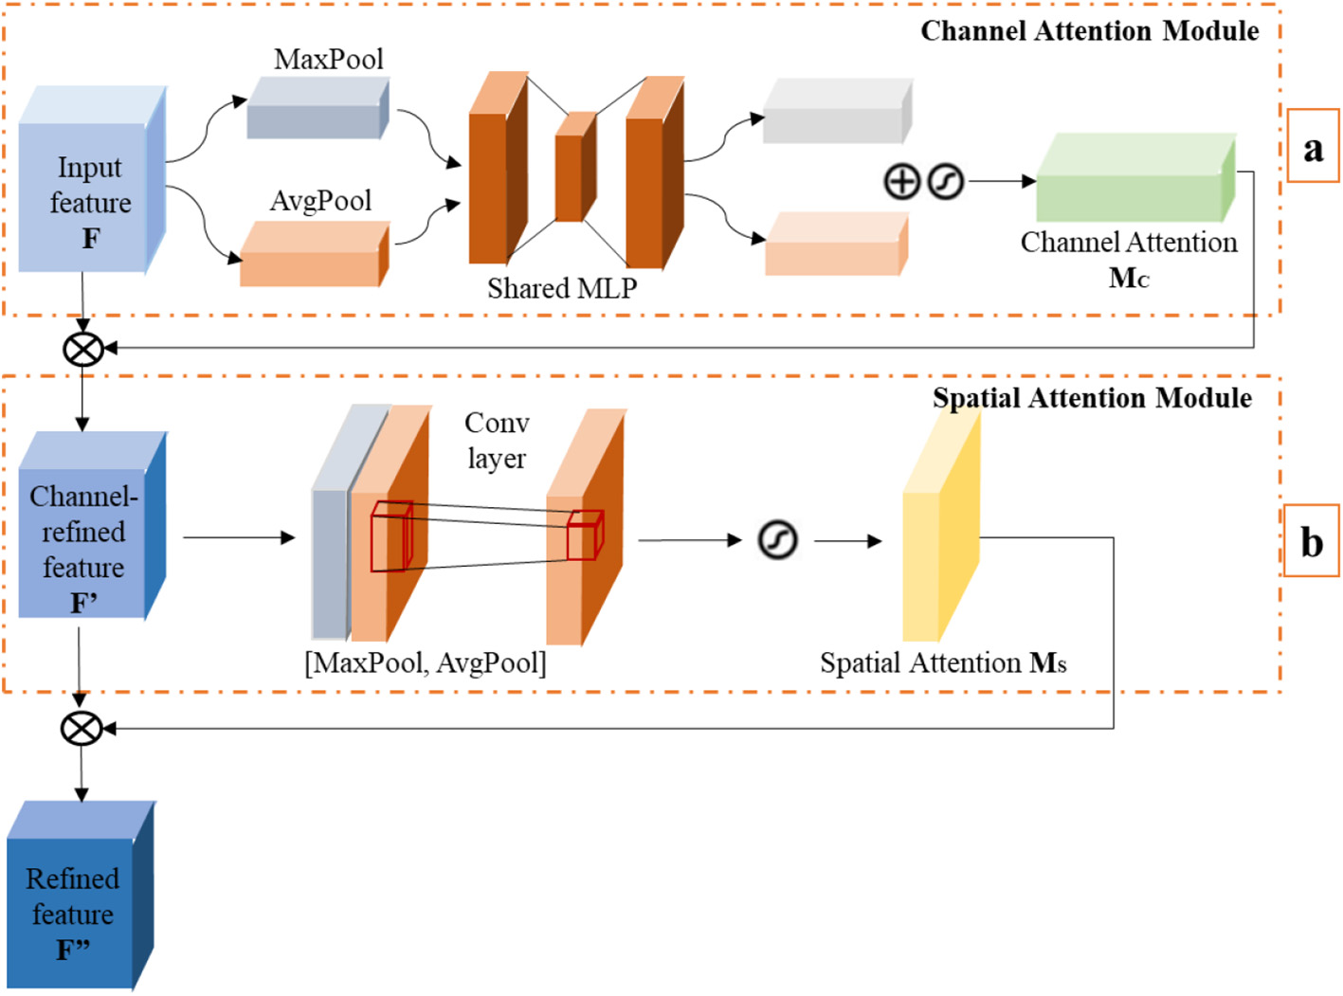

Fig. 3. The structure of the CBAM module.

|  |  |  |  |  |  |
| --- | --- | --- | --- | --- | --- |
| where, σ is the sigmoid function; F′s avgand F′s maxrepresent the feature  maps of size 1 × H × W after average and maximize pooling; f7�7repre-  sents 7 × 7 convolution. Lastly, the Ms and F′ are multiplied to obtain the  final attention feature map F″.  2.3. Performance evaluation | AP ¼ | Z 1 | P rð Þdr | | ð6Þ |
| n mAP ¼1 n∑i¼1 | | | AP ið Þ | ð7Þ |
| where, TP, FP and FN are the numbers of true positive samples, false pos- | | | | |

In the current study, precision, recall, F1 score, mean average preci-sion (mAP) and Frames Per Second (FPS) were adopted as the metrics of the detection accuracy, as shown in the following equations:

|  |  |  |
| --- | --- | --- |
| Precision ¼ | TP  TP þ FP� 100% | ð3Þ |

itive samples and false negative samples, respectively. The mAP is the mean of all classified AP (Average Precision). n represents the number of object categories (n = 1). FPS refers to the number of images identi-fied within 1 s.

2.4. Network training parameters

|  |  |  |  |
| --- | --- | --- | --- |
| Recall ¼ | TP  TP þ FN� 100% | ð4Þ | In this study, all model tests were performed on a computer |
| equipped with a GeForce GTX 1080 Ti GPU, I9-7920× CPU@2.9 GHz. |
| ð5Þ | Parameter settings: 416 × 416 × 3 input size, 1000 training period, 16 |
| F1 ¼ 2 �Precision � Recall Precision þ Recall� 100% | |
| batch size, 0.0013 learning rate. Other parameters are their default |
| settings. |

I Faster R-CNN (Ren et al., 2015), SSD (Liu et al., 2016), YOLOv3

Table 1   
Performance comparison of different algorithms (%).

(Redmon and Farhadi, 2018), EfficientDet (Tan et al., 2020) and YOLOv5s (Liu et al., 2021) serve as comparison models.

|  |  |  |  |  |  |  |
| --- | --- | --- | --- | --- | --- | --- |
| Method | Precision | Recall | F1 | mAP@0.5 | FPS (Frame/s) | 3. Results |
| Faster-rcnn | 79.7 | 95.4 | 86.8 | 90.6 | 2.6 |  |
| SSD | 60.8 | 94.0 | 73.8 | 88.5 | 3.1 | 3.1. Performance of new detection model |
| YOLOv3 | 83.7 | 83.0 | 83.3 | 70.6 | 18.9 |
| EfficientDet | 97.0 | 47.0 | 64.0 | 59.6 | 36 | We used datasets consisting of broiler images at different ages, |
| YOLOv5 | 96.6 | 92.1 | 94.3 | 96.3 | 62 |

|  |  |  |  |  |  |
| --- | --- | --- | --- | --- | --- |
| YOLOv5-CBAM | 97.3 | 92.3 | 94.7 | 96.5 | 55 |

Table 2

Comparison of detection accuracy in different scenes.

raised on two types of litter and multiple pens to test the performance of YOLOv5-CBAM. The detection results of broiler with different models

|  |  |  |  |  |  |  |  |  |  |  |
| --- | --- | --- | --- | --- | --- | --- | --- | --- | --- | --- |
| Method Precision | Fresh pine shavings | |  |  | Reused litter |  |  |  | Multiple pens |  |
|  | d2 | d9 | d16 | d23 | d2 | d9 | d16 | d23 | d16 | d23 |
| Precision of YOLOv5 | 95.1 | 99 | 98.6 | 92.8 | 94.3 | 99 | 99.1 | 98.7 | 92.2 | 98.6 |
| Precision of YOLOv5-CBAM | 96.1 | 99.3 | 99.3 | 94 | 95.2 | 98.9 | 99.3 | 99.3 | 92.5 | 98.8 |

39

Y. Guo, S.E. Aggrey, X. Yang et al. Artificial Intelligence in Agriculture 9 (2023) 36–45

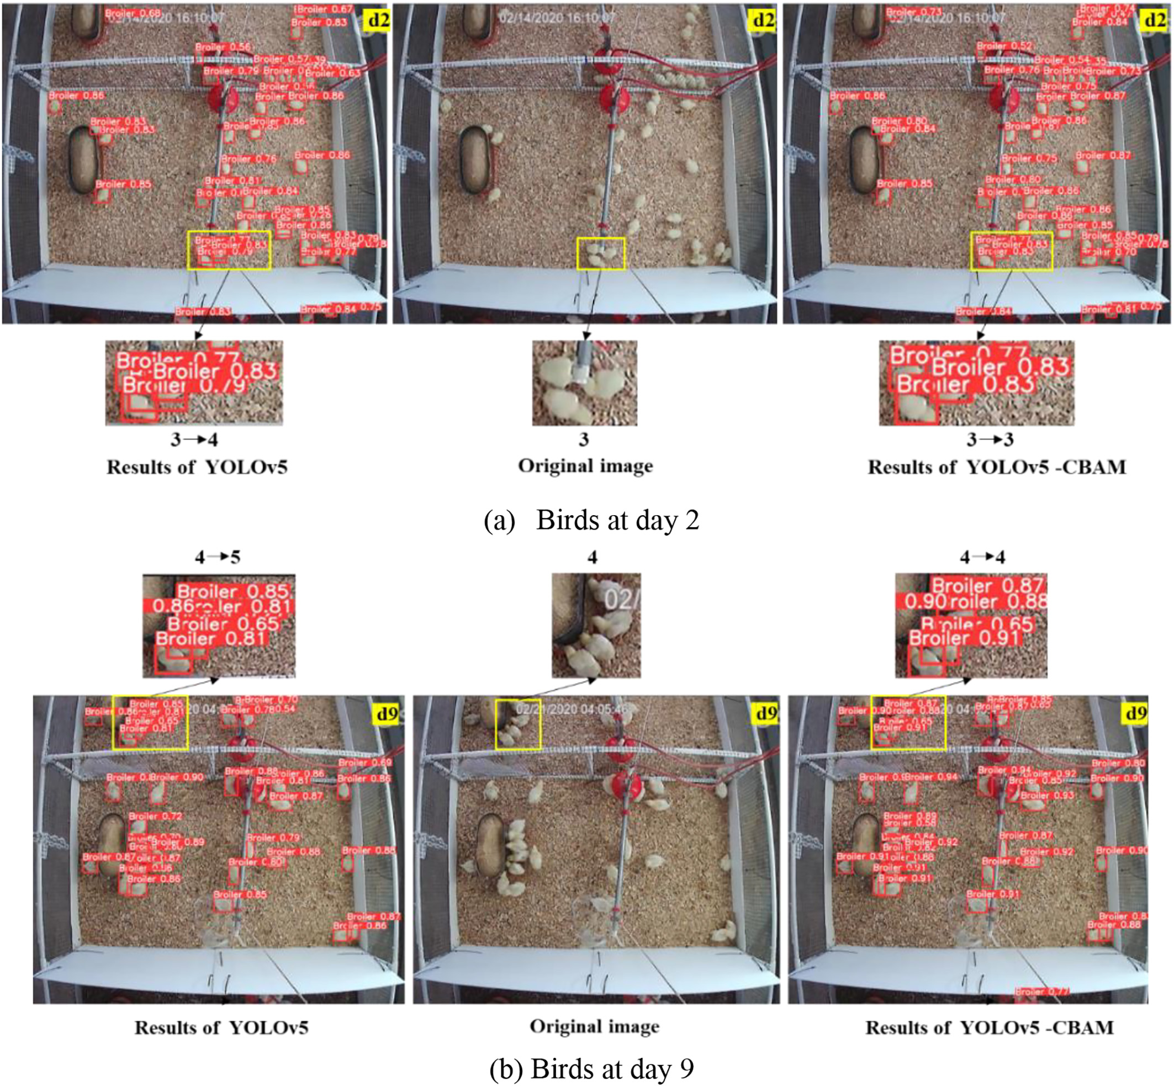

Fig. 4. Detection results using YOLOv5 and YOLOv5-CBAM in fresh pine shavings.

are shown in Table 1. From Table 1, the precision, recall, F1 and mAP@ 0.5 of YOLOv5-CBAM were 97.3%, 92.3%, 94.7% and 96.5%, which was higher than that of YOLOv5 (96.6%, 92.1%, 94.3% and 96.3%), Faster R-CNN (79.7%, 95.4%, 86.8% and 90.6%), SSD (60.8%, 94.0%, 73.8% and 88.5%), YOLOv3 (83.7%, 83.0%, 83.3% and 70.6%) and EfficientDet (97.0%, 47.0%, 64.0% and 59.6%). Adding the CBAM module to YOLOv5 network improved the performance of the broiler detection model. It also showed that the model YOLOv5-CBAM was suitable for the detec-tion of broilers at different growth stages, in different litters type and multiple pens. IThe FPS of YOLOv5-CBAM was 55 Frame/s, which was lower than YOLOv5 (62 Frame/s), but higher than Faster R-CNN (2.6 Frame/s),SSD (3.1 Frame/s), YOLOv3 (18.9 Frame/s) and EfficientDet (36 EfficientDet). It can be seen that the accuracy of YOLOV5-CBAM has also been improved while maintaining a high processing speed, and it can be applied to target detection or small target detection of birds at different feeding densities.

40

Y. Guo, S.E. Aggrey, X. Yang et al. Artificial Intelligence in Agriculture 9 (2023) 36–45

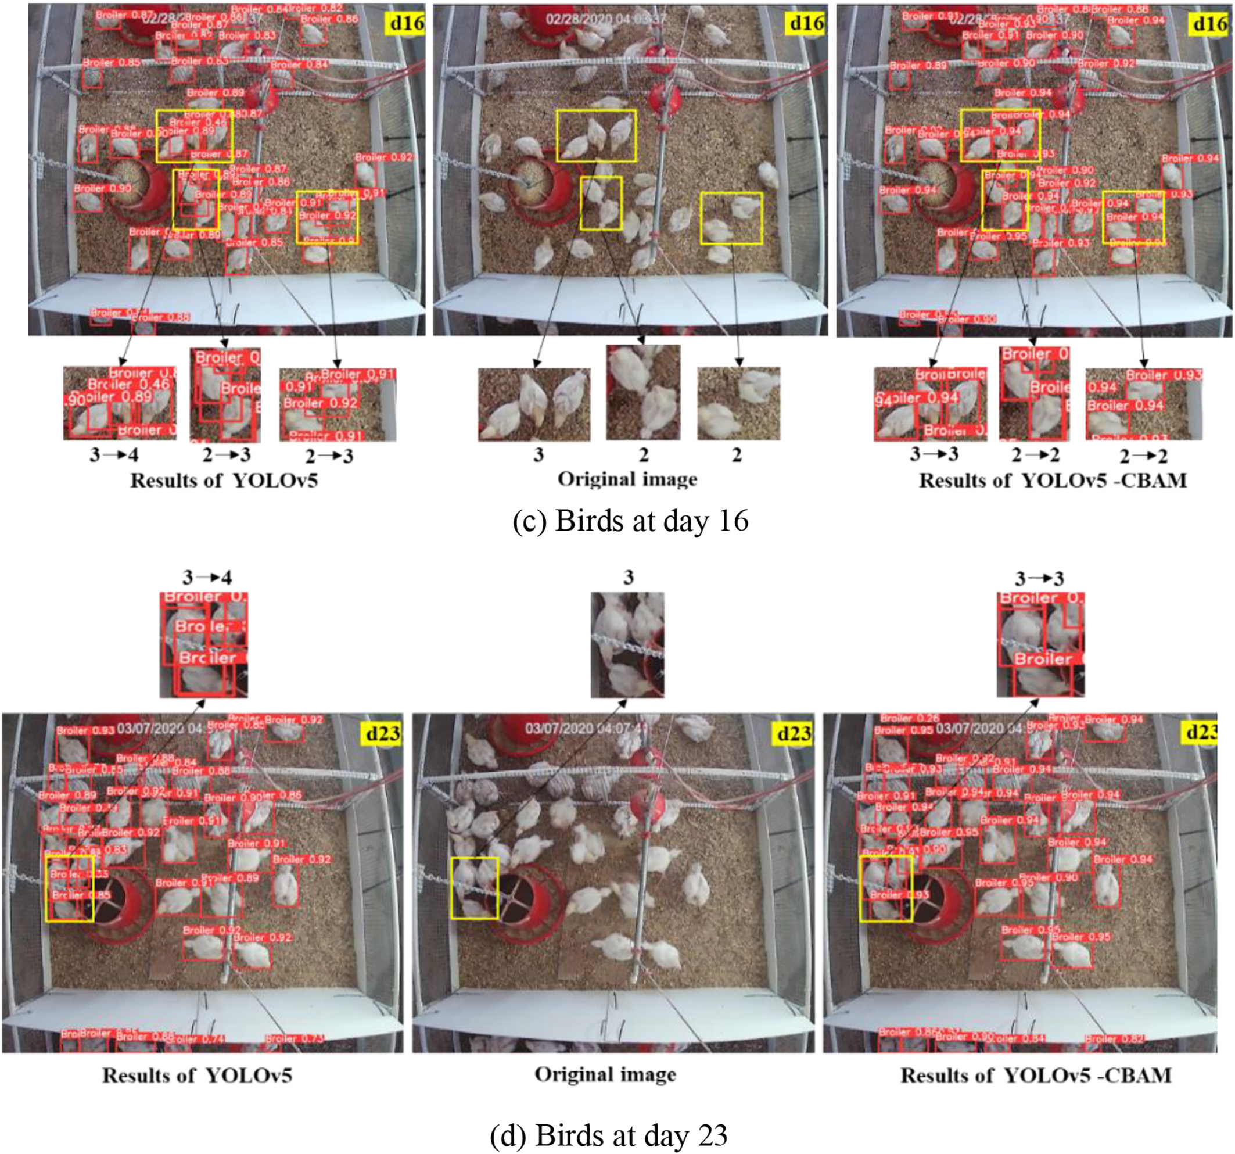

Fig. 4 (continued).

lead to missed or false detection. In addition, the selection of samples will also affect the performance of the test, and the accuracy of the model detection will be reduced when the birds in the sample are too crowded or heavily occluded. This is also the reason for the reduced ac-curacy of YOLOv5-CBAM in d23. Although the precision of YOLOv5-CBAM in each scene was slightly higher than YOLOv5 (Table 2), the overall performance was better than YOLOv5 (Table 1). YOLOv5-CBAM has been improved at different ages, different litter and different population densities, and the generalization performance of the model has also been improved, which can be applied to object detection in dif-ferent feeding environments. It also provides technical support for the accurate detection of commercial broiler breeding.

Fig. 4, Fig. 5, and Fig. 6 shows detection results of YOLOv5 and YOLOv5-CBAM in different scenes (floor types). In Figs. 4 to 6, the

is the original images, and the third column is the detection results of YOLOv5-CBAM. i → j in the Figs. 4 to 6, i is the actual number of broilers, and j is the number of broilers detected broilers. It can be ob-served from Figs. 4 to 6 that in different scenes, YOLOv5-CBAM can detect broilers better than YOLOv5, and in the case of crowded or small targets, it can still provide better detection results. For example, in Fig. 4, YOLOv5 will falsely detect broilers under crowded condi-tions, while YOLOv5-CBAM performed better under crowded condi-tion. However, when the broilers were overcrowded, that is, the broilers overlap and block each other significantly, YOLOv5-CBAM also has false detection (d23 in Fig. 5), but it was lower than YOLOv5. In the case of multiple pens, the edge of the sample image is distorted, and the broiler appears smaller in the field of view, and the occlusion is more substantial and resulted in false detections by

first column is the detection results of YOLOv5, the second column the model (Fig. 6).

41

Y. Guo, S.E. Aggrey, X. Yang et al. Artificial Intelligence in Agriculture 9 (2023) 36–45

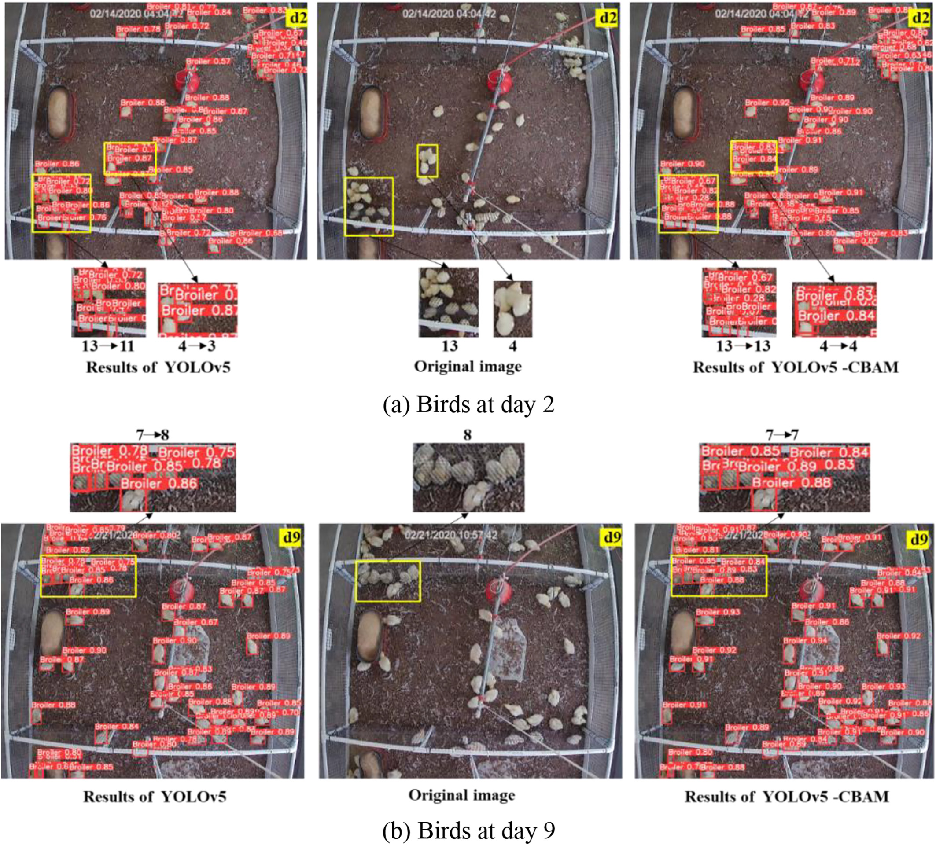

Fig. 5. Detection results using YOLOv5 and YOLOv5-CBAM in reused litter.

4. Discussion will affect the detection performance. In addition, broilers have multiple

angles and poses in the scene, which will also affect the detection accu-

The YOLOv5-CBAM-broiler modle in the current study has a preci-sion of 97.3% for broiler detection on the litter floor, which is higher than that of Faster R-CNN, SSD and YOLOv5 models. The introduction of CBAM attention mechanism can suppress the general features and enhance the important features, thus effectively reducing the missed or false detections. From Table 2 and Figs. 4 to 6, it can be found that adding the CBAM module to YOLOv5 network can improve the detection performance of the model against small or blocked targets. However, when the broilers are significantly blocked or there is a sub-

racy, as shown in Figs. 4 to 6. To sum up, it can be concluded that the se-lection and number of samples will also affect the results.

YOLOv5-CBAM has a small model, high detection accuracy, and FPS of 55 frames/s. It has good real-time performance and can be installed on portable embedded platforms to develop mobile object detection equipment, such as mobile robots. In addition, this method has achieved good detection results in different scenarios, and the samples of differ-ent varieties can be further enriched to further train the model in the later stage, which is expected to achieve multi-target detection under

stantial distortion in the image, YOLOv5-CBAM has the phenomenon different varieties. of false detection or missing detection.

The datasets samples used for model development consisted of dif- 5. Conclusions ferent image scenes of broilers at different ages, raised on litter types

and multiple pens. Therefore, the overall sample contains broilers of dif-ferent sizes, crowding, occlusion, equipment interference, etc., which

42

Y. Guo, S.E. Aggrey, X. Yang et al. Artificial Intelligence in Agriculture 9 (2023) 36–45

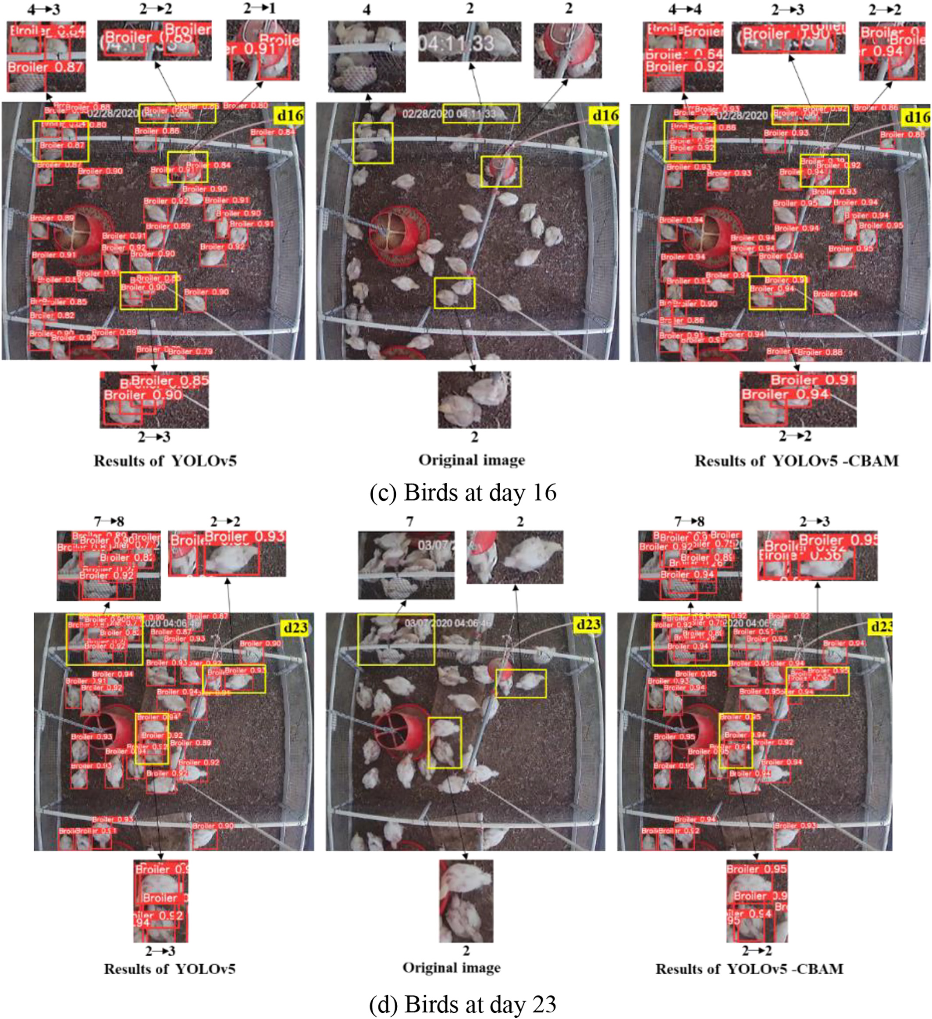

Fig. 5 (continued).

YOLOv5-CBAM-broiler model. The proposed approach integrates CBAM into YOLOv5 and improved the overall detection performance, espe-cially in the case of small targets or occlusions. In addition, the results show that YOLOv5-CBAM could detect broilers of different ages effec-tively and provides the basis for real-time target detection for intelligent

CRediT authorship contribution statement

Yangyang Guo: Data curation, Investigation, Writing - original draft. Samuel E. Aggrey: Resources, Supervision. Xiao Yang: Investigation. Adelumola Oladeinde: Resources, Supervision. Yongliang Qiao: Data

poultry management. curation. Lilong Chai: Conceptualization, Resources, Supervision.

43

Y. Guo, S.E. Aggrey, X. Yang et al. Artificial Intelligence in Agriculture 9 (2023) 36–45

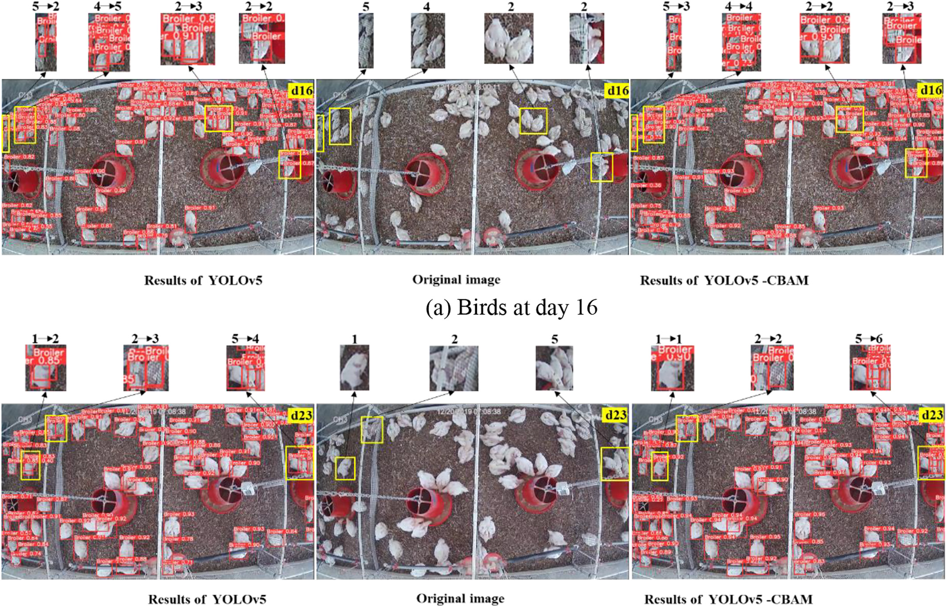

Fig. 6. Detection results using YOLOv5 and YOLOv5-CBAM in multiple pens.

Declaration of Competing Interest

The authors declare that they have no known competing financial interests or personal relationships that could have appeared to influ-ence the work reported in this paper.

Acknowledgements

This study was supported by a cooperative grant 58-6040-6-030 (Lilong Chai) and 58-6040-8-034 (S. E. Aggrey) from the United State Department of Agriculture-Agriculture Research Service; USDA-NIFA Hatch Project (GEO00895): Future Challenges in Animal Production Systems-Seeking Solutions through Focused Facilitation; UGA CAES Dean's Office Research Fund; and Georgia Research Alliance - Venture Fund.

Chai, L., Xin, H., Wang, Y., Oliveira, J., Wang, K., Zhao, Y., 2019. [Mitigating particulate mat-](http://refhub.elsevier.com/S2589-7217(23)00025-9/rf0025) [ter generation in a commercial cage-free hen house. Trans. ASABE 62 (4), 877–886](http://refhub.elsevier.com/S2589-7217(23)00025-9/rf0025). Chen, C., Zhu, W., Norton, T., 2021. Behaviour recognition of pigs and cattle: journey from computer vision to deep learning. Comput. Electron. Agric. 187, 106255. [https://doi.](https://doi.org/10.1016/j.compag.2021.106255)  [org/10.1016/j.compag.2021.106255](https://doi.org/10.1016/j.compag.2021.106255).

Fang, C., Huang, J., Cuan, K., Zhuang, X., Zhang, T., 2020. [Comparative study on poultry tar-get tracking algorithms based on a deep regression network. Biosyst. Eng. 190, 176–183](http://refhub.elsevier.com/S2589-7217(23)00025-9/rf0035).

Fang, C., Zhang, T., Zheng, H., Huang, J., Cuan, K., 2021. [Pose estimation and behavior clas-sif](http://refhub.elsevier.com/S2589-7217(23)00025-9/rf0040)i[cation of broiler chickens based on deep neural networks. Comput. Electron. Agric. 180, 105863](http://refhub.elsevier.com/S2589-7217(23)00025-9/rf0040).

Fukui, H., Hirakawa, T., Yamashita, T., Fujiyoshi, H., 2019. [Attention branch network:](http://refhub.elsevier.com/S2589-7217(23)00025-9/rf0045)  [learning of attention mechanism for visual explanation. Proceedings of the IEEE/](http://refhub.elsevier.com/S2589-7217(23)00025-9/rf0045)  [CVF Conference on Computer Vision and Pattern Recognition, pp. 10705–10714](http://refhub.elsevier.com/S2589-7217(23)00025-9/rf0045). Ge, Z., Liu, S., Wang, F., Li, Z., Sun, J., 2021. Yolox: exceeding yolo series in 2021. arXiv pre- print. <https://doi.org/10.48550/arXiv.2107.08430> arXiv:2107.08430.

Guo, Y., Chai, L., Aggrey, S.E., Oladeinde, A., Johnson, J., Zock, G., 2020. A machine vision-based method for monitoring broiler chicken floor distribution. Sensors 20 (11), 3179. <https://doi.org/10.3390/s20113179>.

Guo, Y.Y., Qiao, Y.L., Sukkarieh, S., Chai, L.L., He, D.J., 2021a. [Bigru-attention based cow be-](http://refhub.elsevier.com/S2589-7217(23)00025-9/rf0060)

|  |  |
| --- | --- |
| References | havior classification using video data for precision livestock farming. Trans. ASABE 64 [(6), 1823–1833](http://refhub.elsevier.com/S2589-7217(23)00025-9/rf0060).  Guo, Y., Aggrey, S.E., Oladeinde, A., Johnson, J., Zock, G., Chai, L., 2021b. A machine vision- |

Alvarez, J.R., Arroqui, M., Mangudo, P., Toloza, J., Jatip, D., Rodriguez, J.M., Teyseyre, A., Sanz, C., Zunino, A., Machado, C., Mateos, C., 2019. Estimating body condition score in dairy cows from depth images using convolutional neural networks, transfer learn-ing and model ensembling techniques. Agronomy 9 (2), 90. [https://doi.org/10.3390/ agronomy9020090](https://doi.org/10.3390/agronomy9020090).

Andrew, W., Greatwood, C., Burghardt, T., 2017. [Visual localisation and individual identi-f](http://refhub.elsevier.com/S2589-7217(23)00025-9/rf0010)i[cation of Holstein friesian cattle via deep learning. Proceedings of the IEEE Interna-tional Conference on Computer Vision Workshops, pp. 2850–2859](http://refhub.elsevier.com/S2589-7217(23)00025-9/rf0010).

Awad, A.I., Zawbaa, H.M., Mahmoud, H.A., Nabi, E.H.H.A., Fayed, R.H., Hassanien, A.E., 2013. [A robust cattle identif](http://refhub.elsevier.com/S2589-7217(23)00025-9/rf0015)i[cation scheme using muzzle print images. In 2013 Fed-erated Conference on Computer Science and Information Systems. IEEE, pp. 529–534](http://refhub.elsevier.com/S2589-7217(23)00025-9/rf0015). Bochkovskiy, A., Wang, C. Y., & Liao, H. Y. M. (2020). Yolov4: optimal speed and accuracy of object detection. arXiv preprint arXiv:2004.10934. Doi: [https://doi.org/10.48550/ arXiv.2004.10934](https://doi.org/10.48550/arXiv.2004.10934).

Chai, L., Zhao, Y., Xin, H., Wang, T., Soupir, M.L., 2018. [Mitigating airborne bacteria gener-ations from cage-free layer litter by spraying acidic electrolysed water. Biosyst. Eng. 170, 61–71](http://refhub.elsevier.com/S2589-7217(23)00025-9/rf0020).

44

Y. Guo, S.E. Aggrey, X. Yang et al.

Li, G., Huang, Y., Chen, Z., Chesser Jr., G.D., Purswell, J.L., Linhoss, J., Zhao, Y., 2021. Practices and applications of convolutional neural network-based computer vision systems in

Artificial Intelligence in Agriculture 9 (2023) 36–45   
Subedi, S., Bist, R.B., Yang, X., Chai, L., 2023a. [Tracking pecking behaviors and damages of cage-free laying hens with machine vision technologies. Comput. Electron. Agric. 204](http://refhub.elsevier.com/S2589-7217(23)00025-9/rf0145)

animal farming: a review. Sensors 21 (4), 1492. <https://doi.org/10.3390/s21041492>. [(1), 107545](http://refhub.elsevier.com/S2589-7217(23)00025-9/rf0145).

Liu, W., Anguelov, D., Erhan, D., Szegedy, C., Reed, S., Fu, C.Y., Berg, A.C., 2016. Ssd: Single shot multibox detector. European Conference on Computer Vision. Springer, Cham, pp. 21–37. <https://doi.org/10.1007/978-3-319-46448-0-2>.

Liu, K., Tang, H., He, S., Yu, Q., Xiong, Y., Wang, N., 2021. Performance validation of YOLO variants for object detection. Proceedings of the 2021 international conference on bioinformatics and intelligent computing, pp. 239–243. [https://doi.org/10.1145/ 3448748.3448786](https://doi.org/10.1145/3448748.3448786).

Okinda, C., Nyalala, I., Korohou, T., Okinda, C., Wang, J., Achieng, T., Wamalwa, T., Manga, T., Shen, M., 2020. A review on computer vision systems in monitoring of poultry: a welfare perspective. Artificial Intelligence in Agriculture 4, 184–208. [https://doi.org/ 10.1016/j.aiia.2020.09.002](https://doi.org/10.1016/j.aiia.2020.09.002).

Qiao, Y., Truman, M., Sukkarieh, S., 2019. Cattle segmentation and contour extraction based on mask R-CNN for precision livestock farming. Comput. Electron. Agric. 165, 104958. <https://doi.org/10.1016/j.compag.2019.104958>.

Qiao, Y., Kong, H., Clark, C., Lomax, S., Su, D., Eiffert, S., Sukkarieh, S., 2021. Intelligent per-ception for cattle monitoring: a review for cattle identification, body condition score evaluation, and weight estimation. Comput. Electron. Agric. 185, 106143. [https://doi. org/10.1016/j.compag.2021.106143](https://doi.org/10.1016/j.compag.2021.106143).

Subedi, S., Bist, R.B., Yang, X., Chai, L., 2023b. [Tracking f](http://refhub.elsevier.com/S2589-7217(23)00025-9/rf0150)l[oor eggs with machine vision in](http://refhub.elsevier.com/S2589-7217(23)00025-9/rf0150)  [cage-free hen houses. Poult. Sci. 102637](http://refhub.elsevier.com/S2589-7217(23)00025-9/rf0150).

Tan, M., Pang, R., Le, Q.V., 2020. [Eff](http://refhub.elsevier.com/S2589-7217(23)00025-9/rf0155)i[cientdet: scalable and eff](http://refhub.elsevier.com/S2589-7217(23)00025-9/rf0155)i[cient object detection. Pro-ceedings of the IEEE/CVF conference on computer vision and pattern recognition, pp. 10781–10790](http://refhub.elsevier.com/S2589-7217(23)00025-9/rf0155).

Tharwat, A., Gaber, T., Hassanien, A.E., 2014. [Cattle identif](http://refhub.elsevier.com/S2589-7217(23)00025-9/rf0160)i[cation based on muzzle images using gabor features and SVM classif](http://refhub.elsevier.com/S2589-7217(23)00025-9/rf0160)i[er. International Conference on Advanced Ma-chine Learning Technologies and Applications. Springer, Cham, pp. 236–247](http://refhub.elsevier.com/S2589-7217(23)00025-9/rf0160).

Tian, M., Guo, H., Chen, H., Wang, Q., Long, C., Ma, Y., 2019. Automated pig counting using deep learning. Comput. Electron. Agric. 163, 104840. [https://doi.org/10.1016/j. compag.2019.05.049](https://doi.org/10.1016/j.compag.2019.05.049).

Wang, Z., Song, H., Wang, Y., Hua, Z., Li, R., Xu, X., 2022. [Research progress on intelligent morning methods of dairy Cow’s motion behavior. Smart Agriculture 1–18 (2022-06-12)](http://refhub.elsevier.com/S2589-7217(23)00025-9/rf0170).

Woo, S., Park, J., Lee, J.Y., Kweon, I.S., 2018. [Cbam: convolutional block attention module. Proceedings of the European Conference on Computer Vision (ECCV), pp. 3–19](http://refhub.elsevier.com/S2589-7217(23)00025-9/rf0175).

Xue, H., Qin, J., Quan, C., Ren, W., Gao, T., Zhao, J., 2021. Open set sheep face recognition based on euclidean space metric. Math. Probl. Eng. 1-5. [https://doi.org/10.1155/](https://doi.org/10.1155/2021/3375394)

Qin, Q., Liu, Z., Zhao, C., Zhang, C., Dai, D., Sun, J., Wang, Z., Li, J., 2021. [Application of ma-](http://refhub.elsevier.com/S2589-7217(23)00025-9/rf0125) [2021/3375394](https://doi.org/10.1155/2021/3375394).

[chine vision Technology in Livestock and Poultry. Agric. Eng. 11 (07), 27–33](http://refhub.elsevier.com/S2589-7217(23)00025-9/rf0125).

Redmon, J., Farhadi, A., 2018. Yolov3: An incremental improvement. arXiv preprint. <https://doi.org/10.48550/arXiv.1804.02767>.

Ren, S., He, K., Girshick, R., Sun, J., 2015. [Faster r-cnn: towards real-time object detection](http://refhub.elsevier.com/S2589-7217(23)00025-9/rf0135)  [with region proposal networks. Adv. Neural Inf. Proces. Syst. 28](http://refhub.elsevier.com/S2589-7217(23)00025-9/rf0135).

Shen, W., Hu, H., Dai, B., Wei, X., Sun, J., Jiang, L., Sun, Y., 2020. [Individual identif](http://refhub.elsevier.com/S2589-7217(23)00025-9/rf0140)i[cation of dairy cows based on convolutional neural networks. Multimed. Tools Appl. 79 (21), 14711–14724](http://refhub.elsevier.com/S2589-7217(23)00025-9/rf0140).

45